Name :

Abubaker Attique

Roll num :

P20-0560

Section :

BCs 5A

Lab : 14 (FAST NETWORK) :

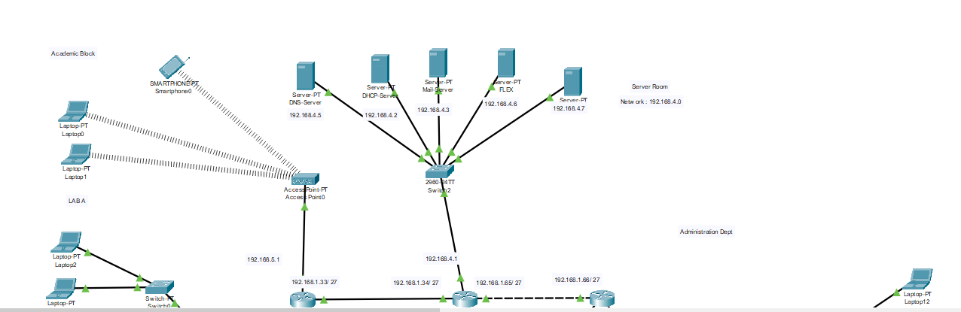

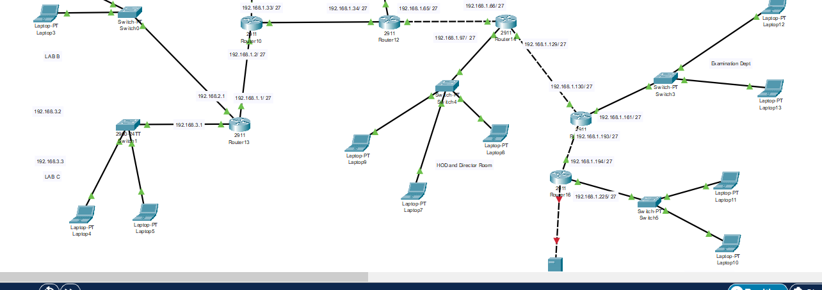

**Academic Block :**

**Lab A configuration :**

In lab A we use a wireless switch for connection between PC’s and Router. The Network for this lab is **192.168.5.0/24**. We assign ip’s dynamically to PC’s by creating a pool on the router.

**DHCP Router Configuration:**

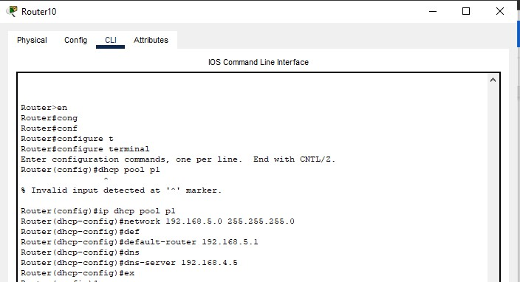

**Assigning IP’s to Laptops using DHCP Router:**

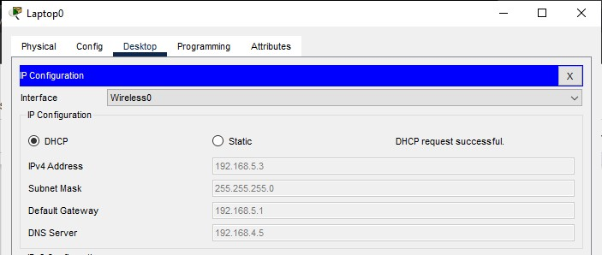

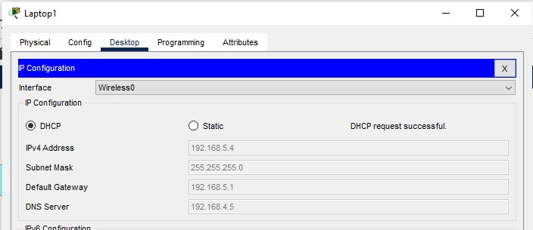

**Lab B configuration :**

In this lab we use a simple Switch for Connection. The Network for this lab is **192.168.2.0/24.** Here we assign ip’s also dynamically to PC’s by creating a pool ‘P2’on the router.

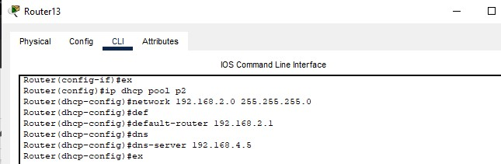

**Assigning IP’s to Laptops using DHCP Router:**

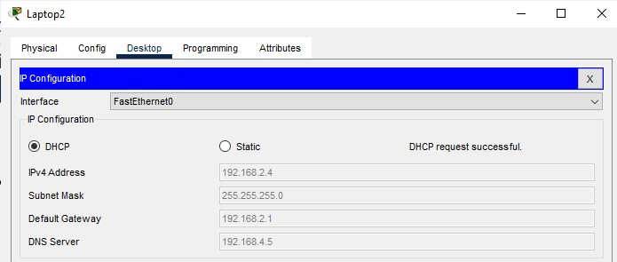

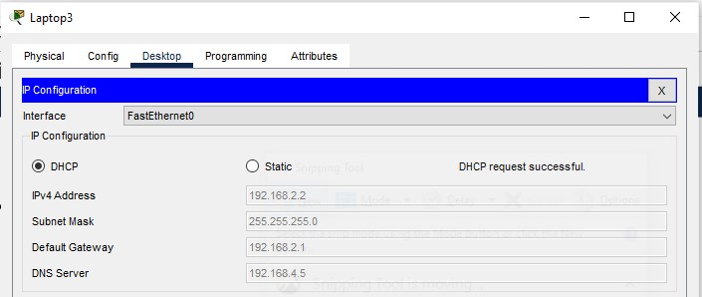

**Lab C configuration :**

The Network for this lab is **192.168.3.0/24.** Here we assign ip’s Statically to PC’s.

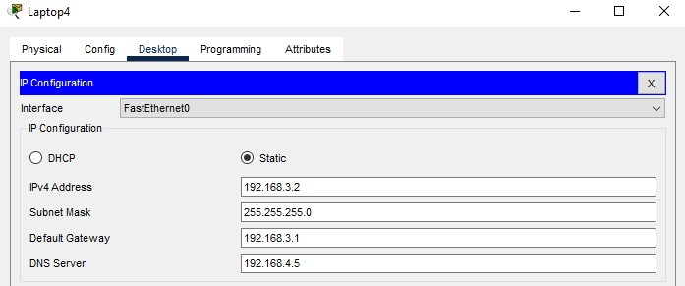

**Administration Block:**

In Administration Block we have three Main blocks

**1.Director & HOD’s portion:**

In this block the network we use is a subnetted one (**192.168.1.96/27**). We use the DHCP Server to assign IP’s dynamically to the PC’s.

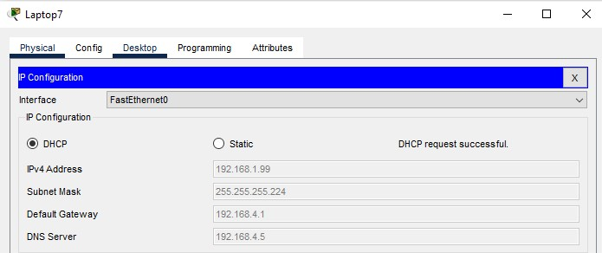

For this Network we created a pool in the DHCP server.

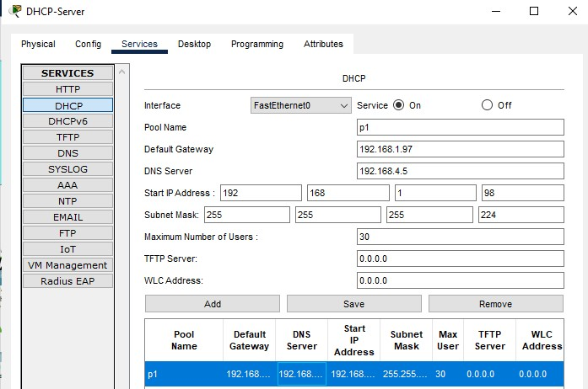

1. **Finance Dept:**

In this portion the network we use is also a subnetted one (**192.168.1.224/27**). We also use the DHCP Server to assign IP’s dynamically to the PC’s.

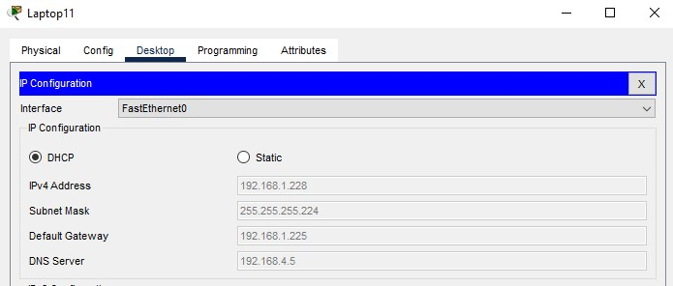

For this Network we also created a pool in the DHCP server.

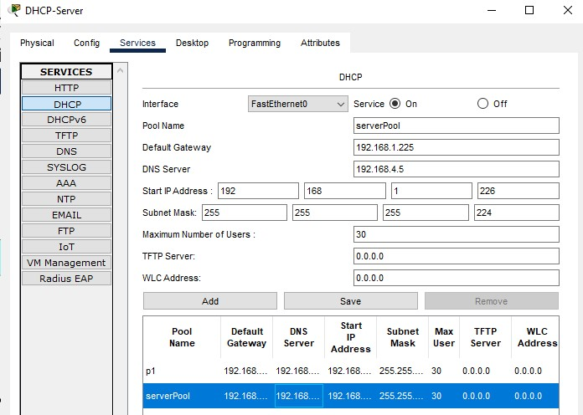

1. **Examination Dept:**

In this portion the network we use is also a subnetted one

(**192.168.1.160/27**). We assign ip’s dynamically to the PC’s by creating a pool on the router.

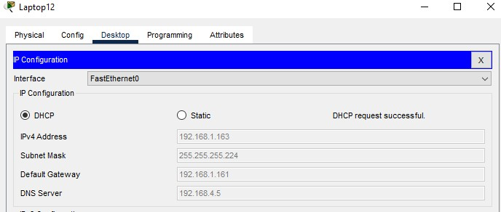

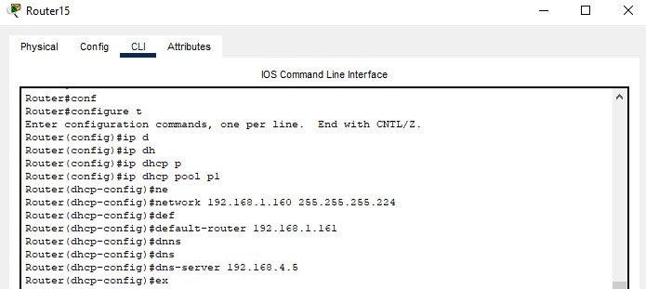

**Server Room Configuration:**

**DNS Server :**

Assigning static IP to the DNS server.

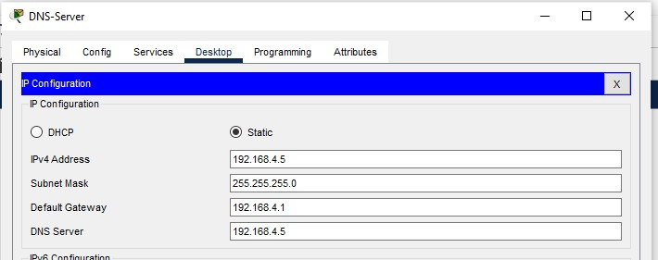

Activating DNS services

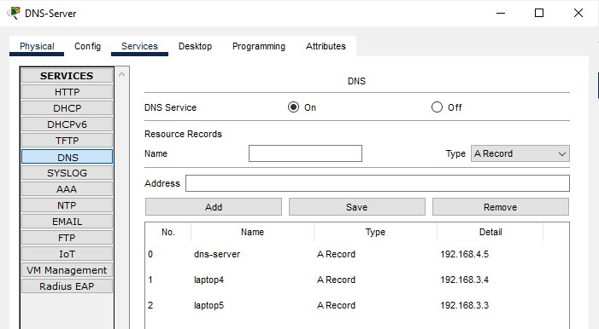

**DHCP Server :**

Assigning static IP to the DHCP server.

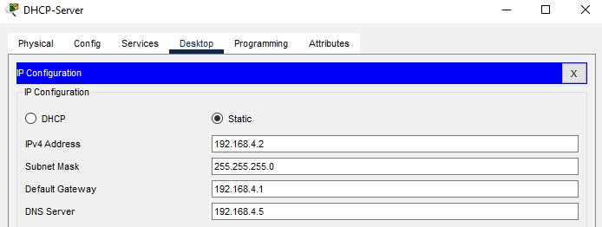

Activating DHCP services by creating Poolsfor different Networks Used In topology.

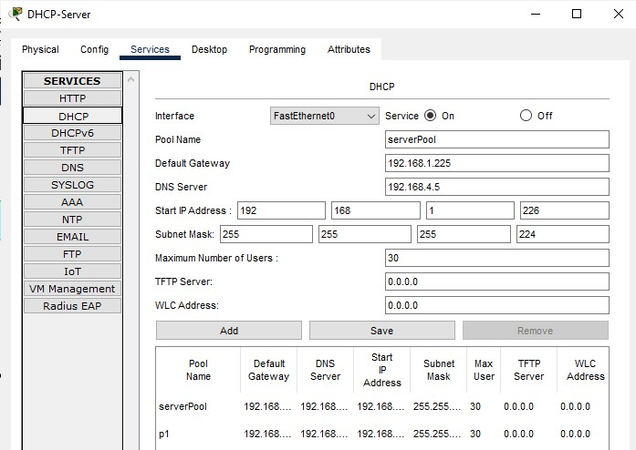

**FLEX server:**

Assigning static IP to Flex server.

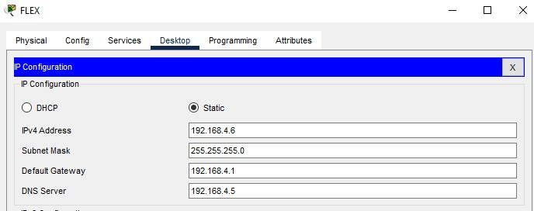

Activating HTTP services and creating “Flex.html” file and uploading it to server using FT.

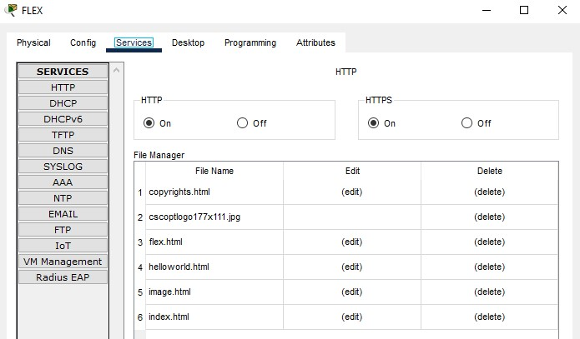

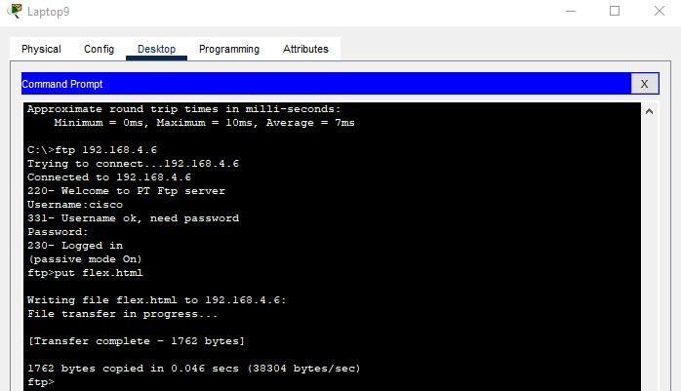

**Slate server:**

Assigning static IP to Slate server.

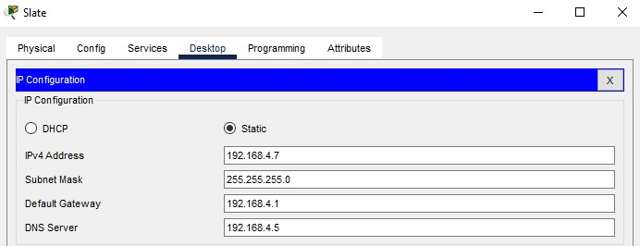

Activating HTTP services and creating “Slate.html” file and uploading it to server using FTP.

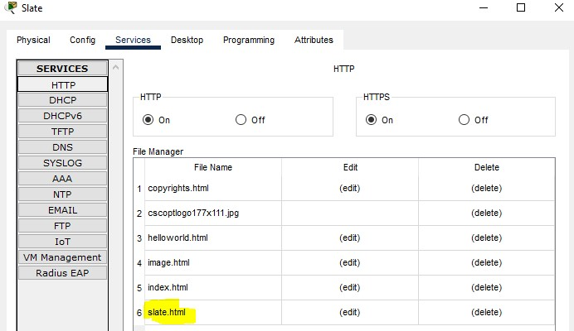

**Router Configuration:**

We have a total of Six routers used in this topology. Here i used **Network**

**Subnetting Concept** because the network between the Routers require only two ip’s, So for reducing the Wastage i used the Network

**192.168.1.0/27** and subnetted it in to **8** different networks and used all these networks in the p;ace where ip requirement is less.

**Router 10:**

Configuration :

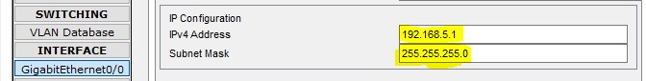

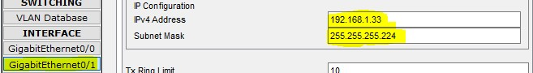

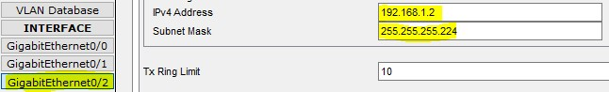

**Static Routes of Router 10:**

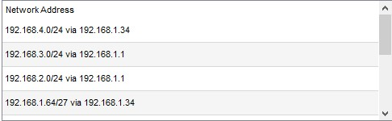

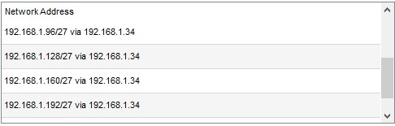

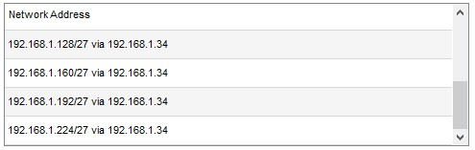

The same process is repeated for all the Routers. The networks and the static routes are given in the Packet tracer File.

**Checking Connectivity: Servers :**

Accessing Dns server from a PC in Academic block:

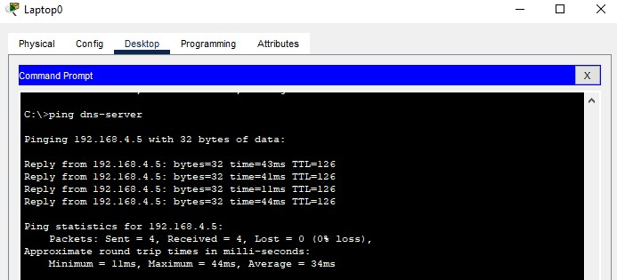

Accessing Dns-server from Administration Block:

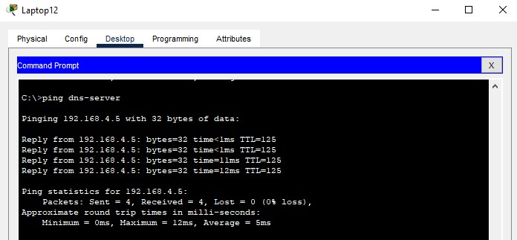

Accessing FLEX Server from Academic Block:

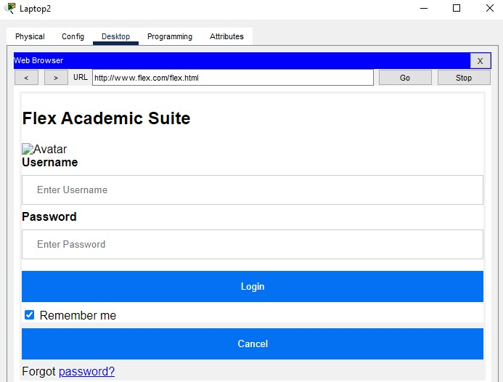

**PC’s :**

Accessing an Academic PC from Examination Dept of Administration:

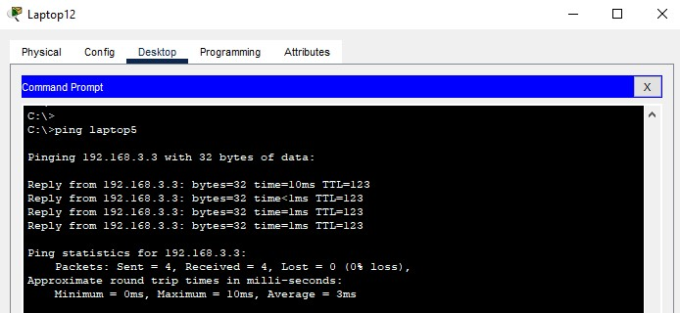

Accessing Slate server from Administration Block :

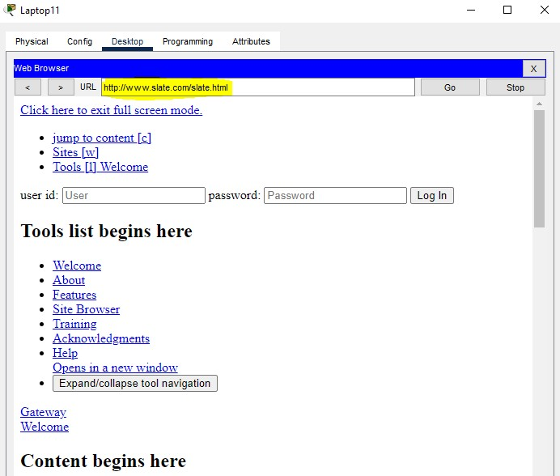

**PC’s :**

Accessing an Academic PC from Examination Dept:

